# Interactive Dashboard

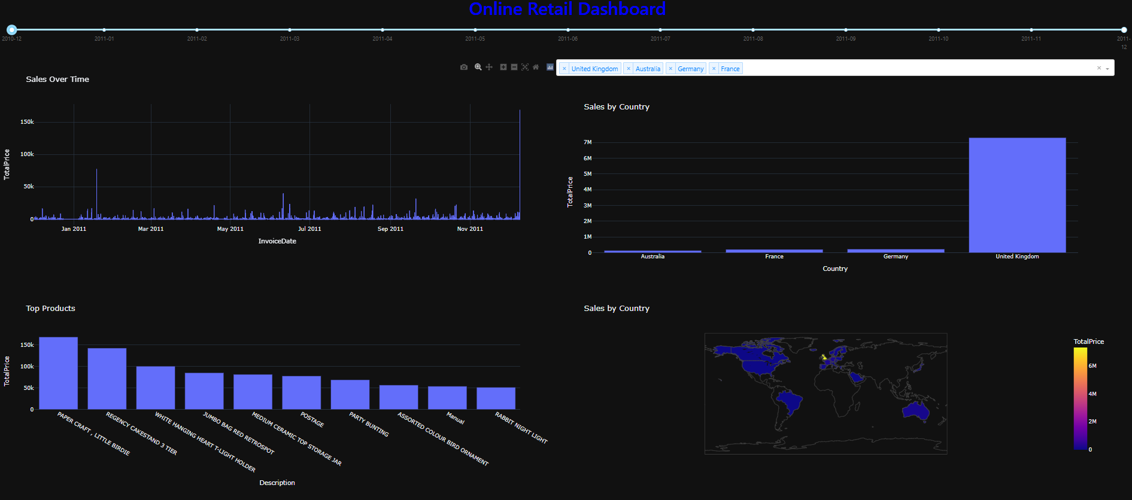

Figure 7 Visual representation of the top section of the dashboard

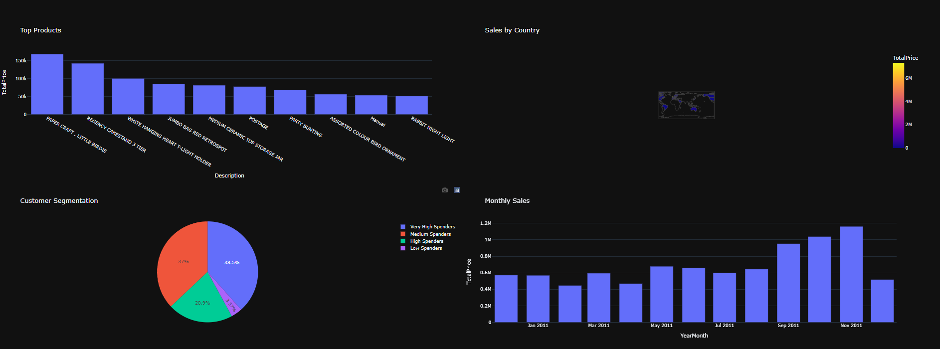

Figure 1 Visual representation of the bottom section of the dashboard

The interactive dashboard is designed to summarize key aspects of an online retail dataset, targeted at younger adults aged 18-35 years. It provides a comprehensive view of the data through various visualizations, highlighting sales trends, customer segments, and geographical sales distribution. The design and interactivity make it engaging and easy to use, appealing to the younger demographic.

Design Rationale:

The color scheme uses dark backgrounds with contrasting colors (blue for the title and various colors for the charts) to create a visually appealing interface.

The clean and modern layout ensures that the information is presented in a structured manner, making it easy to navigate and understand.

Interactivity:

The use of interactive elements such as the date range slider and country dropdown allows users to filter and explore the data dynamically. This makes the dashboard engaging and user-friendly.

Visual Appeal:

The design focuses on clear and concise visualizations that convey information effectively. The use of charts and maps helps in presenting the data in a manner that is easy to interpret, which is crucial for the younger audience who prefer quick and visually-driven information.

## Data Preparation and Visualization

Data Cleaning:

Removing Null Values: Missing values in the CustomerID and Description columns were dropped to ensure data quality.

Filtering Data: Rows with non-positive Quantity values were removed to eliminate invalid transactions.

Feature Engineering:

TotalPrice Calculation: A new column TotalPrice was created by multiplying Quantity and UnitPrice, providing a key metric for sales analysis.

Date Features: The InvoiceDate column was converted to datetime format, and additional features such as YearMonth, DayOfWeek, and Day were extracted to enable time-based analysis.

Visualizations:

Sales Over Time: A line chart showing total sales over time helps identify sales trends and seasonal patterns.

Sales by Country: A bar chart displaying sales by country provides insights into geographical distribution and market performance.

Top Products: A bar chart of the top 10 products by sales helps identify the best-performing products.

Sales Map: A choropleth map visualizes sales distribution across different countries, highlighting key markets.

Customer Segmentation: A pie chart segments customers based on their total spending, identifying key customer groups.

Monthly Sales: A bar chart showing total sales for each month provides an easy-to-understand view of sales performance over time.

Machine Learning Suitability:

Comprehensive Data: The dataset includes various features such as product description, quantity, price, and transaction date, which are essential for building machine learning models.

Segmentation and Trend Analysis: The visualizations help in identifying customer segments and sales trends, which are crucial for predictive modelling and targeted marketing strategies.

Geographical Analysis: The geographical sales distribution can be used for location-based recommendation and demand forecasting.

## Deploying the app with Dash

The Online Retail Dashboard was successfully deployed using Dash (dash.plotly.com, n.d.), a powerful Python framework for building web-based analytical applications. A detailed README is provided that contains step-by-step instructions on setting up the environment, running the application, and accessing the dashboard to explore the visualizations and insights it offers.

## Conclusion

The dashboard successfully meets the requirements by providing an interactive and visually appealing platform for analysing online retail data. The design and interactivity cater to the younger demographic, making it engaging and easy to use. The data preparation and visualizations provide a comprehensive view of the dataset, highlighting its suitability for machine learning applications in an online retail business.